Triangle Circumcenter

Definition
# Source: AI Source: Provided by: [Data Path: Persons Table -> ID Column: 1, Name_En Column: Motasem Essam] -> From: [ChatGPT] on [7/25/2026]
The Triangle Circumcenter is the point where the three perpendicular bisectors of the sides of a triangle intersect.
The circumcenter is commonly denoted by:
$$\boxed{O}$$
For triangle $△ABC$, if the perpendicular bisectors of $\overset{‾}{AB}$, $\overset{‾}{BC}$, and $\overset{‾}{CA}$intersect at $O$, then $O$is the circumcenter.
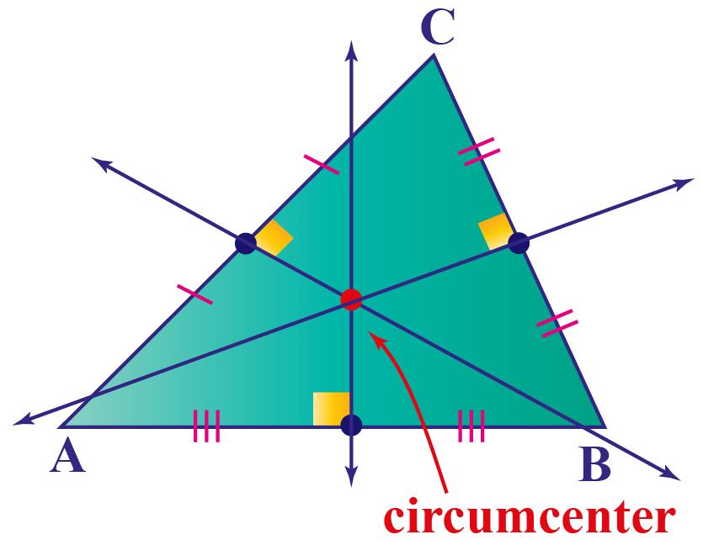
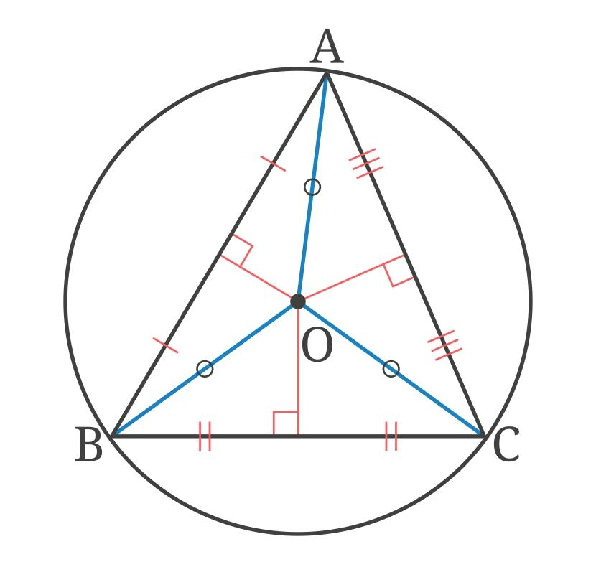
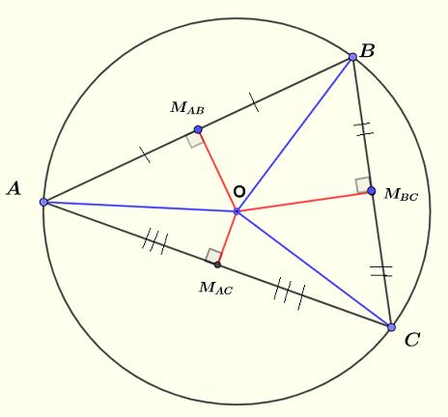
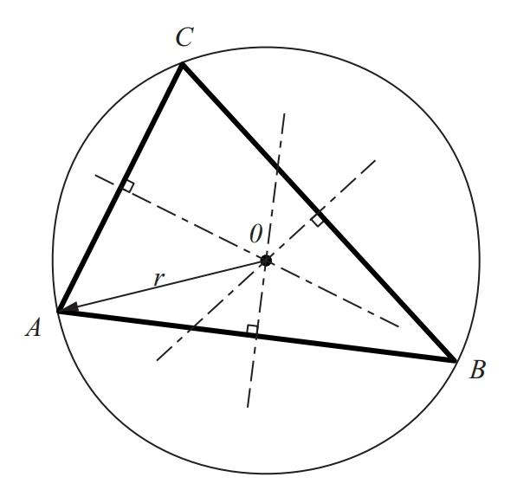
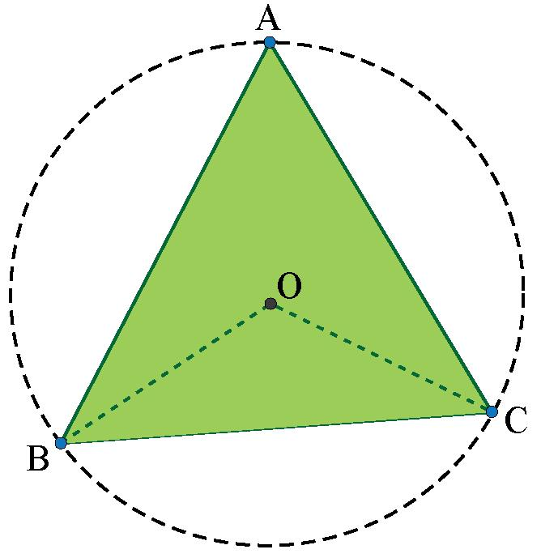

Purpose
# Source: AI Source: Provided by: [Data Path: Persons Table -> ID Column: 1, Name_En Column: Motasem Essam] -> From: [ChatGPT] on [7/25/2026]
The circumcenter is used to:
- Locate the center of the circumcircle.
- Determine the circumradius of a triangle.
- Find a point equidistant from all three vertices.
- Study perpendicular bisectors and their relationships with triangles.
- Solve coordinate-geometry problems.
- Determine whether a triangle is acute, right, or obtuse from the location of its circumcenter.

Fundamental Elements
# Source: AI Source: Provided by: [Data Path: Persons Table -> ID Column: 1, Name_En Column: Motasem Essam] -> From: [ChatGPT] on [7/25/2026]
For $△ABC$:
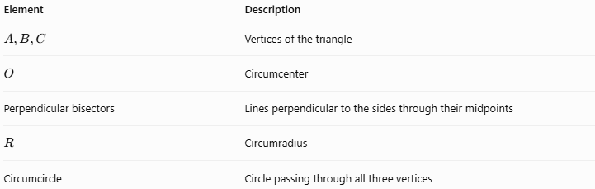
Element | Description
$$A,B,C$$ | Vertices of the triangle
$$O$$ | Circumcenter
Perpendicular bisectors | Lines perpendicular to the sides through their midpoints
$$R$$ | Circumradius
Circumcircle | Circle passing through all three vertices
The defining relationship is:
$$\boxed{O=\text{intersection of the three perpendicular bisectors}}$$

Perpendicular Bisectors
# Source: AI Source: Provided by: [Data Path: Persons Table -> ID Column: 1, Name_En Column: Motasem Essam] -> From: [ChatGPT] on [7/25/2026]
A perpendicular bisector of a segment is a line that:
- passes through the segment's midpoint, and
- is perpendicular to the segment.
For side $\overset{‾}{AB}$, its perpendicular bisector contains every point that is equally distant from $A$and $B$.
Therefore, if $O$lies on the perpendicular bisector of $AB$:
$$\boxed{OA=OB}$$
Similarly:
$$\boxed{OB=OC}$$
and:
$$\boxed{OC=OA}$$
Therefore:
$$\boxed{OA=OB=OC}$$

Circumcenter Theorem
# Source: AI Source: Provided by: [Data Path: Persons Table -> ID Column: 1, Name_En Column: Motasem Essam] -> From: [ChatGPT] on [7/25/2026]
The Circumcenter Theorem states:
The perpendicular bisectors of the three sides of a nondegenerate triangle are concurrent at a single point called the circumcenter.
Thus:
$$\boxed{\text{Perpendicular Bisector}\left(AB\right)∩\text{Perpendicular Bisector}\left(BC\right)∩\text{Perpendicular Bisector}\left(CA\right)=\left\{O\right\}}$$
The circumcenter is the unique point equidistant from the three vertices.

Circumcircle
# Source: AI Source: Provided by: [Data Path: Persons Table -> ID Column: 1, Name_En Column: Motasem Essam] -> From: [ChatGPT] on [7/25/2026]
The circumcircle is the circle that passes through all three vertices of a triangle.
Its center is the circumcenter $O$.
Its radius is called the circumradius, denoted by $R$.
Therefore:
$$\boxed{OA=OB=OC=R}$$
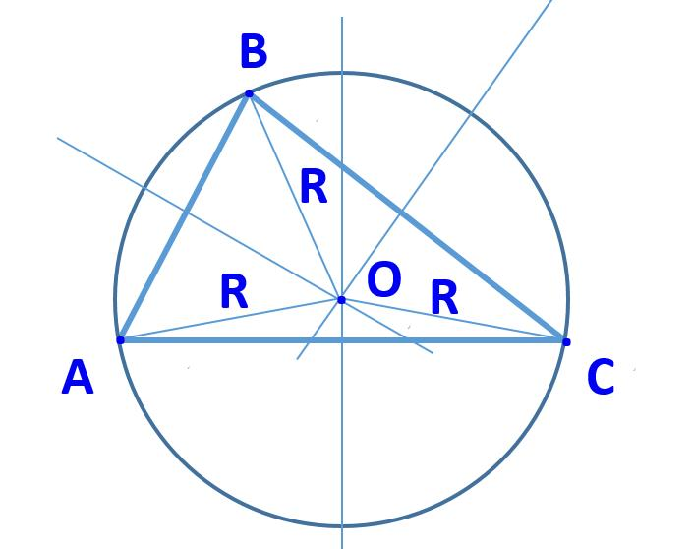
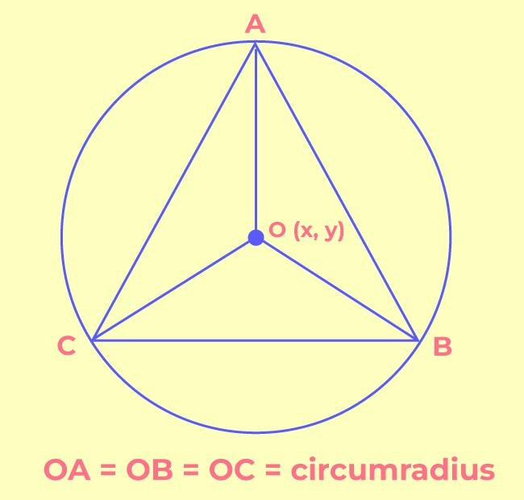
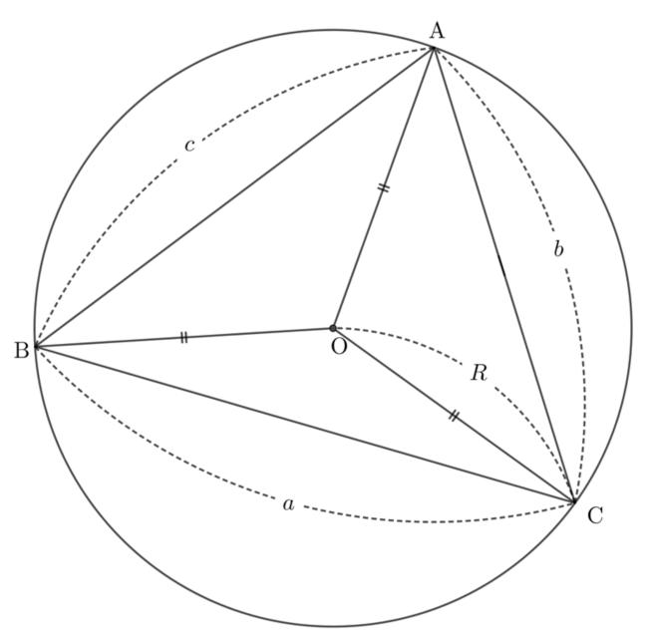
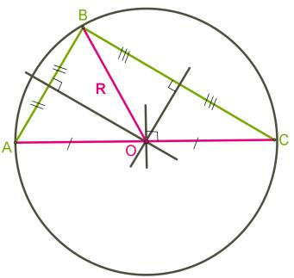

Circumcircle Equation
# Source: AI Source: Provided by: [Data Path: Persons Table -> ID Column: 1, Name_En Column: Motasem Essam] -> From: [ChatGPT] on [7/25/2026]
If the circumcenter is:
$$O=\left(h , k\right)$$
and the circumradius is $R$, then the circumcircle has equation:
$$\boxed{{\left(x-h\right)}^{2}+{\left(y-k\right)}^{2}=R^{2}}$$
Every vertex of the triangle satisfies this equation.
For example:
$$A=\left(x_{1} , y_{1}\right)$$
lies on the circumcircle if:
$${\left(x_{1}-h\right)}^{2}+{\left(y_{1}-k\right)}^{2}=R^{2}$$

Location of the Circumcenter
# Source: AI Source: Provided by: [Data Path: Persons Table -> ID Column: 1, Name_En Column: Motasem Essam] -> From: [ChatGPT] on [7/25/2026]
Unlike the centroid and incenter, the circumcenter is not always inside the triangle.
Its location depends on the type of triangle.

Acute Triangle
# Source: AI Source: Provided by: [Data Path: Persons Table -> ID Column: 1, Name_En Column: Motasem Essam] -> From: [ChatGPT] on [7/25/2026]
For an acute triangle:
$$\boxed{O\text{ lies inside the triangle}}$$
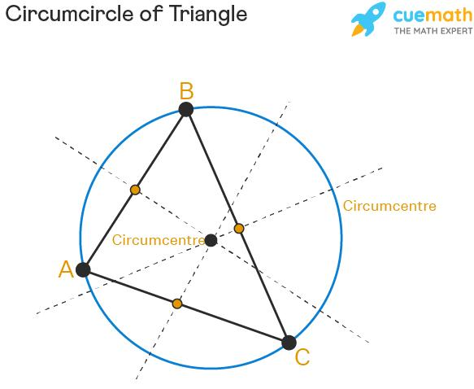
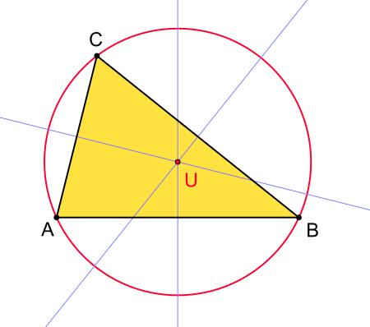

Right Triangle
# Source: AI Source: Provided by: [Data Path: Persons Table -> ID Column: 1, Name_En Column: Motasem Essam] -> From: [ChatGPT] on [7/25/2026]
For a right triangle, the circumcenter is the midpoint of the hypotenuse.
If $AB$is the hypotenuse:
$$\boxed{O=\text{midpoint of }AB}$$
and:
$$\boxed{R=\frac{AB}{2}}$$
This follows from Thales' theorem.
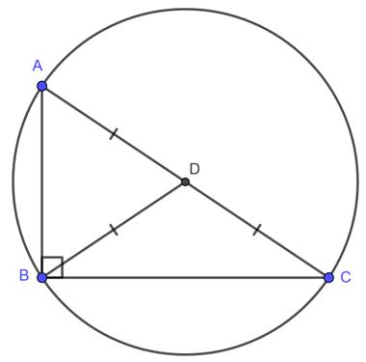
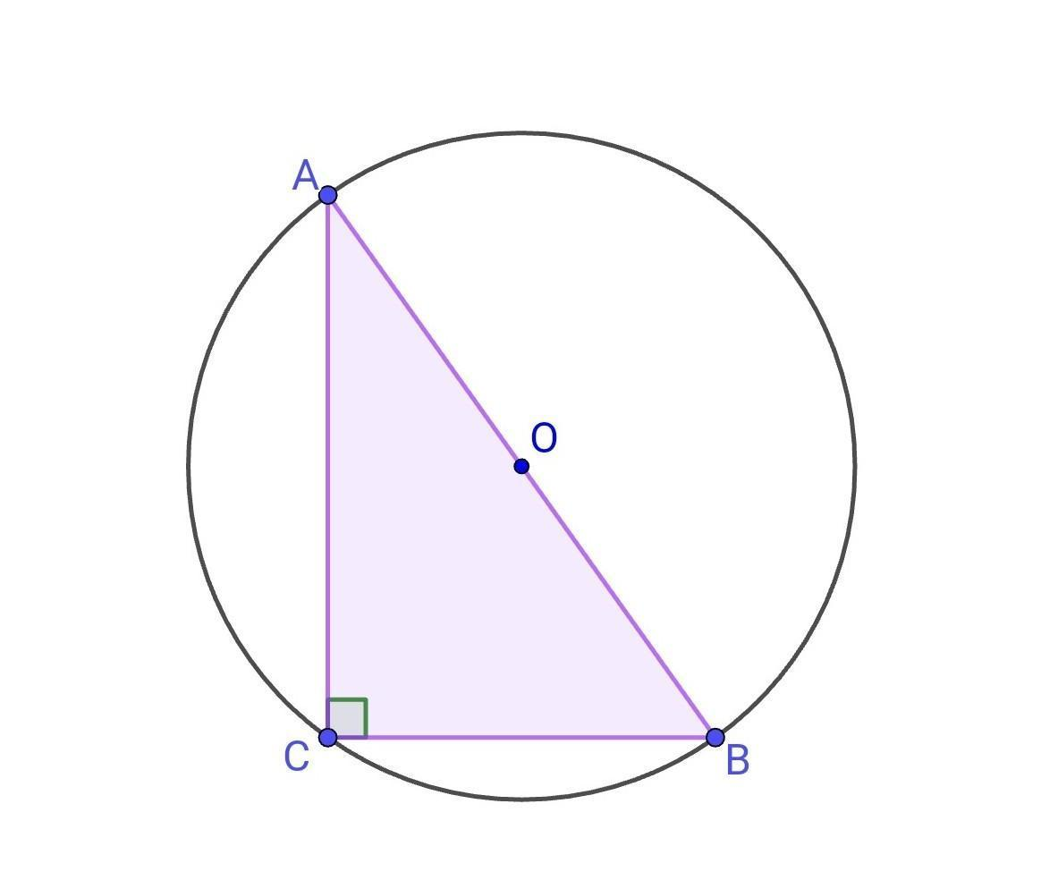
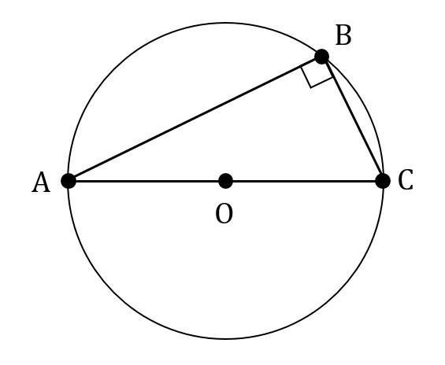
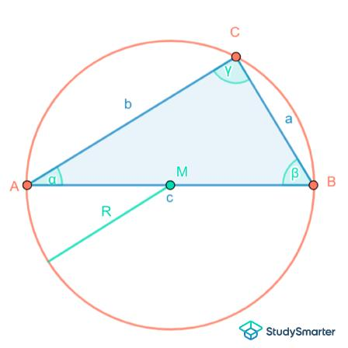
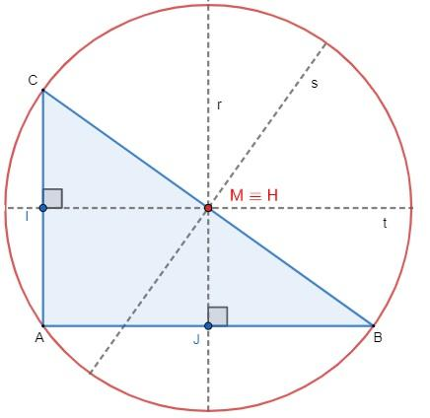

Obtuse Triangle
# Source: AI Source: Provided by: [Data Path: Persons Table -> ID Column: 1, Name_En Column: Motasem Essam] -> From: [ChatGPT] on [7/25/2026]
For an obtuse triangle:
$$\boxed{O\text{ lies outside the triangle}}$$
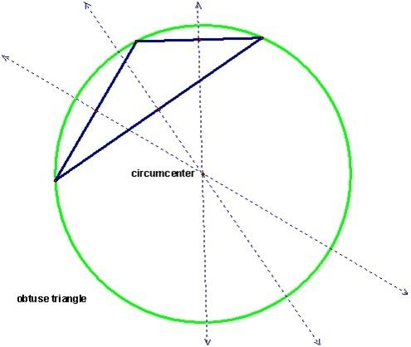
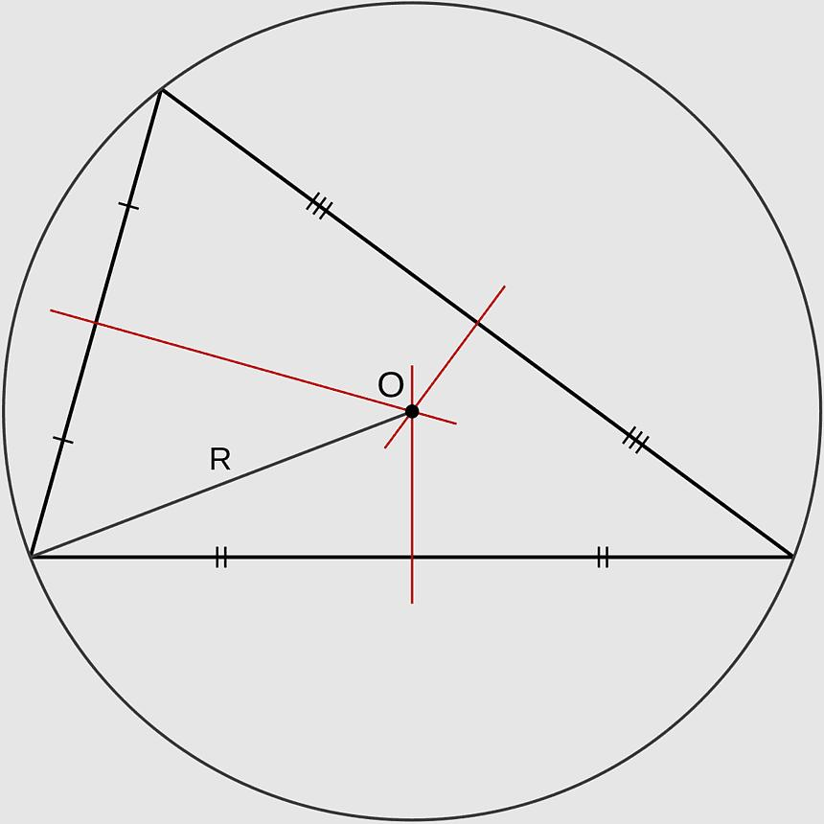
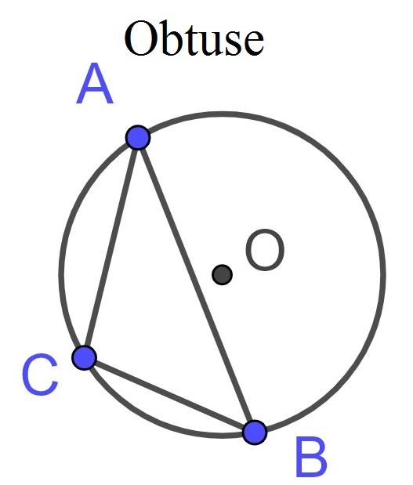
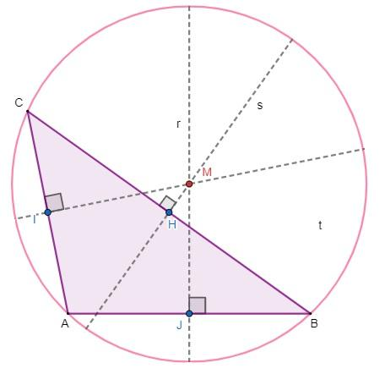
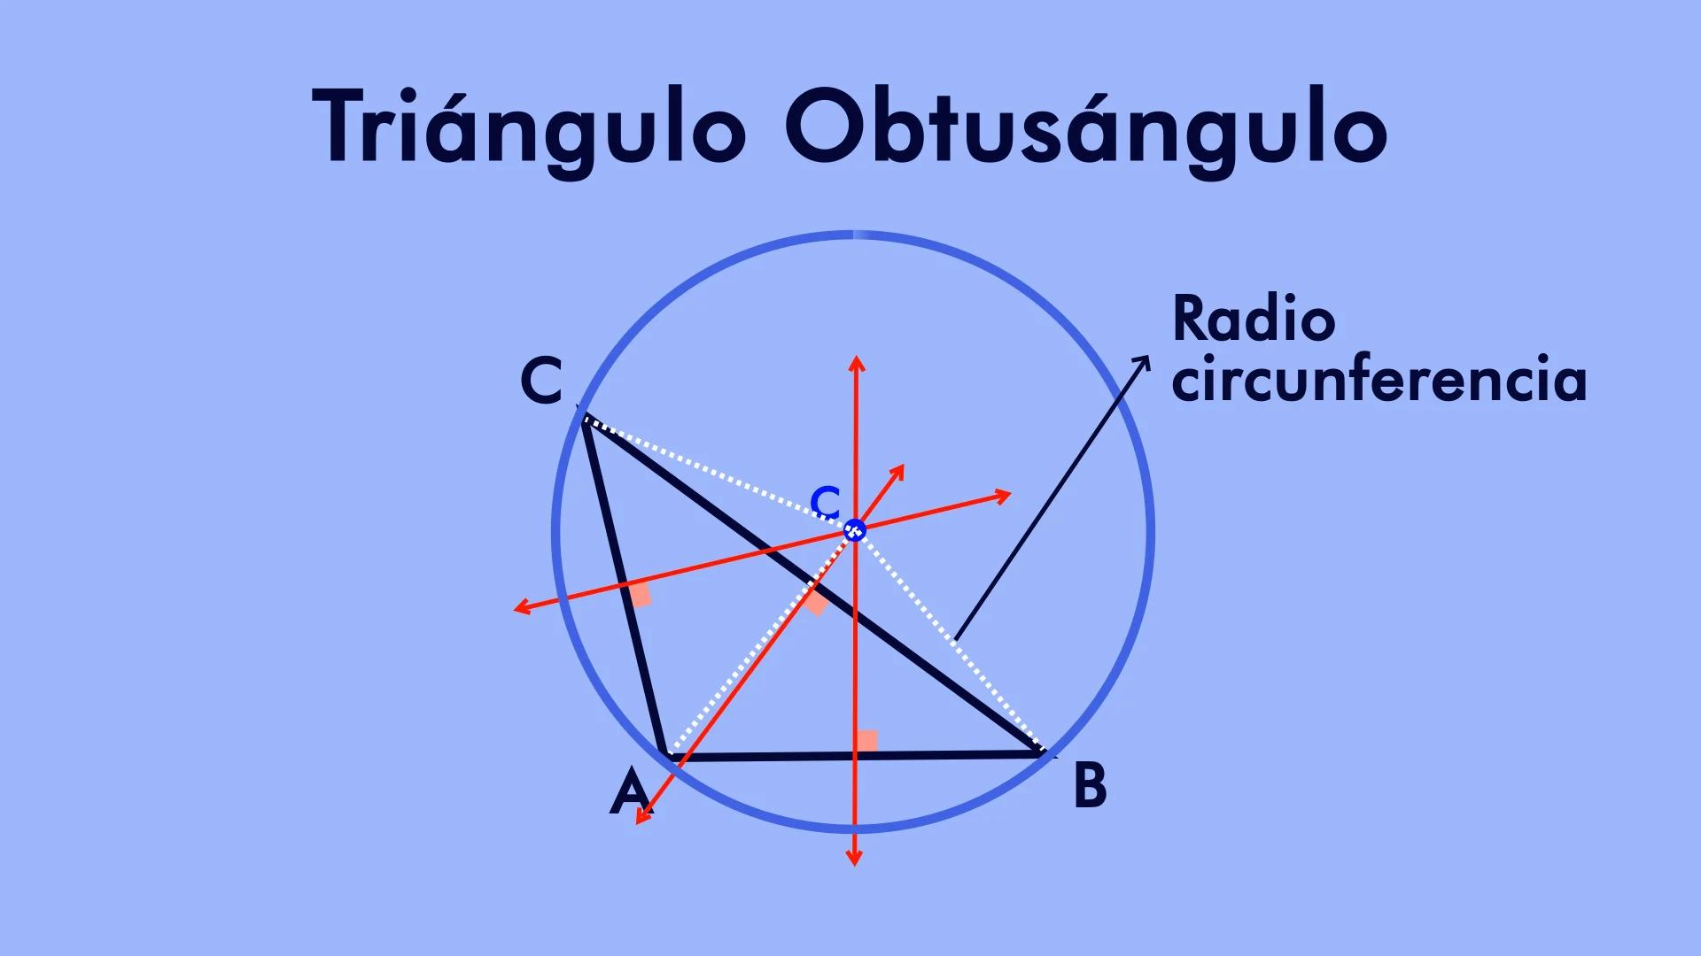

Summary of Circumcenter Location
# Source: AI Source: Provided by: [Data Path: Persons Table -> ID Column: 1, Name_En Column: Motasem Essam] -> From: [ChatGPT] on [7/25/2026]
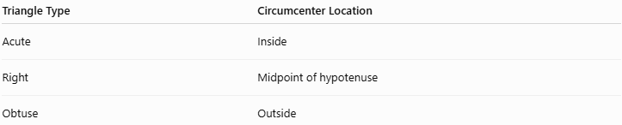
Triangle Type | Circumcenter Location
Acute | Inside
Right | Midpoint of hypotenuse
Obtuse | Outside
This is an important distinction between the circumcenter and the centroid/incenter.

Coordinate Formula
# Source: AI Source: Provided by: [Data Path: Persons Table -> ID Column: 1, Name_En Column: Motasem Essam] -> From: [ChatGPT] on [7/25/2026]
Suppose the triangle vertices are:
$$A=\left(x_{1} , y_{1}\right) \\ B=\left(x_{2} , y_{2}\right) \\ C=\left(x_{3} , y_{3}\right)$$
The circumcenter can be found by solving the equations obtained from:
$$OA^{2}=OB^{2}$$
and:
$$OA^{2}=OC^{2}$$
If:
$$O=\left(h , k\right)$$
then:
$${\left(h-x_{1}\right)}^{2}+{\left(k-y_{1}\right)}^{2}={\left(h-x_{2}\right)}^{2}+{\left(k-y_{2}\right)}^{2}$$
and:
$${\left(h-x_{1}\right)}^{2}+{\left(k-y_{1}\right)}^{2}={\left(h-x_{3}\right)}^{2}+{\left(k-y_{3}\right)}^{2}$$
The quadratic terms cancel, leaving two linear equations in $h$and $k$.

Example: Right Triangle
# Source: AI Source: Provided by: [Data Path: Persons Table -> ID Column: 1, Name_En Column: Motasem Essam] -> From: [ChatGPT] on [7/25/2026]
Consider:
$$A=\left(0 , 0\right) \\ B=\left(6 , 0\right) \\ C=\left(0 , 8\right)$$
The triangle is right-angled at $A$.
The hypotenuse is:
$$\overset{‾}{BC}$$
Its midpoint is:
$$O=\left(\frac{6+0}{2} , \frac{0+8}{2}\right)$$
Therefore:
$$\boxed{O=\left(3 , 4\right)}$$
The hypotenuse has length:
$$BC=\sqrt{6^{2}+8^{2}}=10$$
Therefore the circumradius is:
$$R=\frac{10}{2} \\ \boxed{R=5}$$

Circumradius Formula
# Source: AI Source: Provided by: [Data Path: Persons Table -> ID Column: 1, Name_En Column: Motasem Essam] -> From: [ChatGPT] on [7/25/2026]
For a triangle with side lengths $a,b,c$and area $K$, the circumradius is:
$$\boxed{R=\frac{abc}{4K}}$$
Therefore:
$$\boxed{K=\frac{abc}{4R}}$$
Another important formula uses one side and its opposite angle:
$$\boxed{a=2R\sin{A}}$$
Similarly:
$$\boxed{b=2R\sin{B}}$$
and:
$$\boxed{c=2R\sin{C}}$$
These are forms of the Extended Law of Sines.

Circumcenter and Perpendicular Bisector Theorem
# Source: AI Source: Provided by: [Data Path: Persons Table -> ID Column: 1, Name_En Column: Motasem Essam] -> From: [ChatGPT] on [7/25/2026]
The circumcenter depends directly on the Perpendicular Bisector Theorem.
The theorem states:
A point lies on the perpendicular bisector of a segment if and only if it is equidistant from the segment's endpoints.
Thus:
$$O∈\text{perpendicular bisector of }AB$$
if and only if:
$$OA=OB$$
Since the circumcenter satisfies:
$$OA=OB=OC$$
it must lie on all three perpendicular bisectors.

Circumcenter and Circumcircle Relationship
# Source: AI Source: Provided by: [Data Path: Persons Table -> ID Column: 1, Name_En Column: Motasem Essam] -> From: [ChatGPT] on [7/25/2026]
The relationship can be summarized as:
$$\boxed{\text{Perpendicular Bisectors}→\text{Circumcenter}→\text{Circumcircle}}$$
Specifically:
$$\boxed{OA=OB=OC=R}$$

Circumcenter vs Incenter
# Source: AI Source: Provided by: [Data Path: Persons Table -> ID Column: 1, Name_En Column: Motasem Essam] -> From: [ChatGPT] on [7/25/2026]
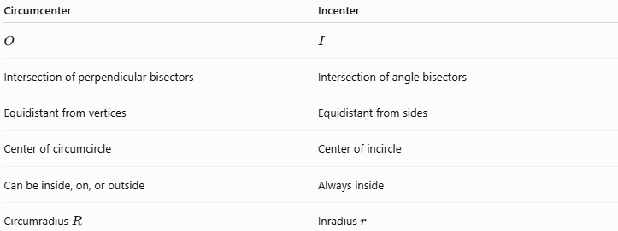
Circumcenter | Incenter
$$O$$ | $$I$$
Intersection of perpendicular bisectors | Intersection of angle bisectors
Equidistant from vertices | Equidistant from sides
Center of circumcircle | Center of incircle
Can be inside, on, or outside | Always inside
Circumradius $R$ | Inradius $r$

Circumcenter vs Centroid
# Source: AI Source: Provided by: [Data Path: Persons Table -> ID Column: 1, Name_En Column: Motasem Essam] -> From: [ChatGPT] on [7/25/2026]
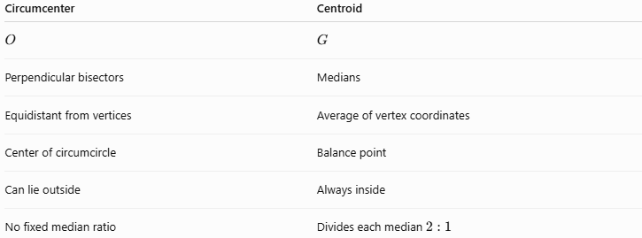
Circumcenter | Centroid
$$O$$ | $$G$$
Perpendicular bisectors | Medians
Equidistant from vertices | Average of vertex coordinates
Center of circumcircle | Balance point
Can lie outside | Always inside
No fixed median ratio | Divides each median $2:1$

Circumcenter vs Orthocenter
# Source: AI Source: Provided by: [Data Path: Persons Table -> ID Column: 1, Name_En Column: Motasem Essam] -> From: [ChatGPT] on [7/25/2026]
The circumcenter and orthocenter are also closely related.
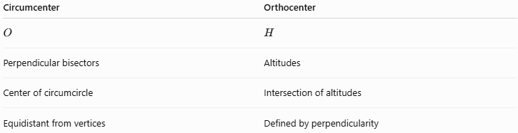
Circumcenter | Orthocenter
$$O$$ | $$H$$
Perpendicular bisectors | Altitudes
Center of circumcircle | Intersection of altitudes
Equidistant from vertices | Defined by perpendicularity
In an equilateral triangle:
$$\boxed{O=H}$$

Triangle Centers
# Source: AI Source: Provided by: [Data Path: Persons Table -> ID Column: 1, Name_En Column: Motasem Essam] -> From: [ChatGPT] on [7/25/2026]
The four principal triangle centers can be organized as follows:
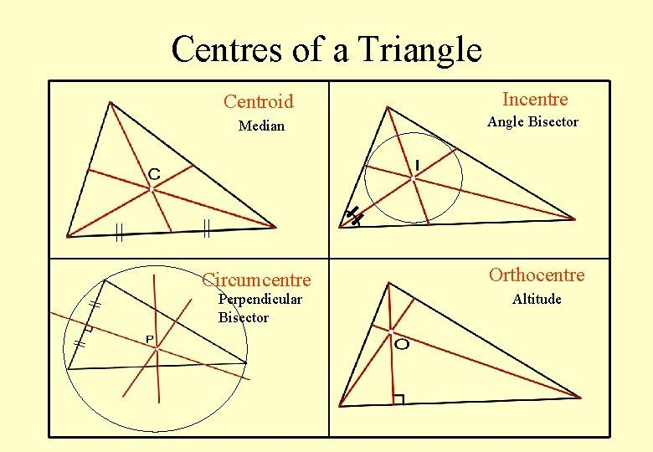
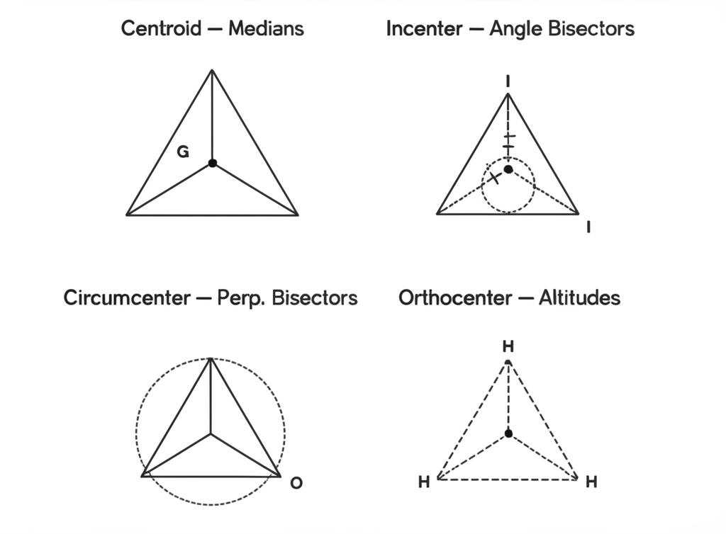
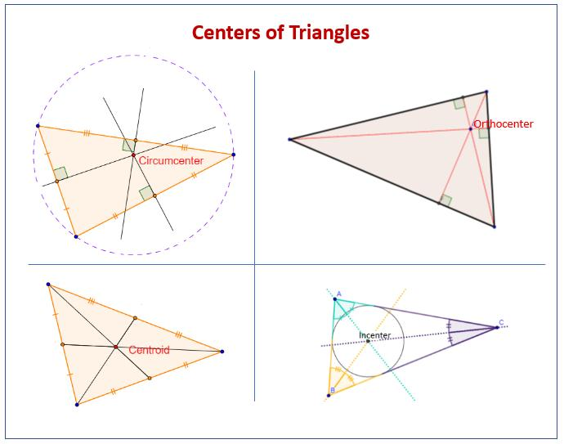
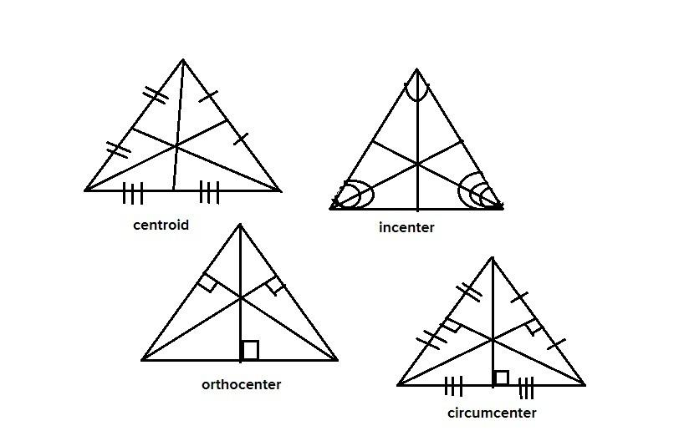
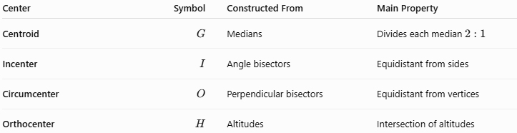
Center | Symbol | Constructed From | Main Property
Centroid | $$G$$ | Medians | Divides each median $2:1$
Incenter | $$I$$ | Angle bisectors | Equidistant from sides
Circumcenter | $$O$$ | Perpendicular bisectors | Equidistant from vertices
Orthocenter | $$H$$ | Altitudes | Intersection of altitudes

Special Case: Equilateral Triangle
# Source: AI Source: Provided by: [Data Path: Persons Table -> ID Column: 1, Name_En Column: Motasem Essam] -> From: [ChatGPT] on [7/25/2026]
In an equilateral triangle, the principal triangle centers coincide:
$$\boxed{G=I=O=H}$$
Therefore, the centroid, incenter, circumcenter, and orthocenter are all the same point.

Key Properties
# Source: AI Source: Provided by: [Data Path: Persons Table -> ID Column: 1, Name_En Column: Motasem Essam] -> From: [ChatGPT] on [7/25/2026]
- Every nondegenerate triangle has exactly one circumcenter.
- The circumcenter is the intersection of the three perpendicular bisectors.
- The circumcenter is equidistant from all three vertices:
$$\boxed{OA=OB=OC}$$
- This common distance is the circumradius $R$.
- The circumcenter is the center of the circumcircle.
- The circumcircle passes through all three vertices.
- In an acute triangle, the circumcenter is inside.
- In a right triangle, it is the midpoint of the hypotenuse.
- In an obtuse triangle, it is outside.
- The circumradius satisfies:
$$\boxed{R=\frac{abc}{4K}}$$

Related Concepts
# Source: AI Source: Provided by: [Data Path: Persons Table -> ID Column: 1, Name_En Column: Motasem Essam] -> From: [ChatGPT] on [7/25/2026]
The circumcenter is directly related to:
- Perpendicular Bisector
- Perpendicular Bisector Theorem
- Circumcircle
- Circumradius
- Thales' Theorem
- Extended Law of Sines
- Triangle Centers
- Medians
- Angle Bisectors
- Altitudes
- Euler Line

Conclusion
# Source: AI Source: Provided by: [Data Path: Persons Table -> ID Column: 1, Name_En Column: Motasem Essam] -> From: [ChatGPT] on [7/25/2026]
The Triangle Circumcenter is the unique point where the three perpendicular bisectors of a triangle's sides intersect. It is the center of the circumcircle and is equally distant from all three vertices.
Its fundamental relationships are:
$$\boxed{O=\text{intersection of the three perpendicular bisectors}} \\ \boxed{OA=OB=OC=R}$$
and:
$$\boxed{R=\frac{abc}{4K}}$$
Unlike the centroid and incenter, the circumcenter may lie inside, on, or outside the triangle depending on whether the triangle is acute, right, or obtuse.

